Housing Authority Management

A short-term or long-term bond issued by state or local governments to help finance the construction or rehabilitation of affordable rental housing. Under certain programs, the proceeds from Housing Authority bonds may also be used to help low-income individuals and families purchase a home.

Table used:

-housing_authorities:

currently we have following housig authority in cms.

YEIDA,GNIDA,Affordable Housing,NBCC,GDA,Armed Forces Officials Welfare Organisation,CMDA,UPAVP,Millennium Housing Cooperative Society,Senior Citizen Housing

- Housing Authority

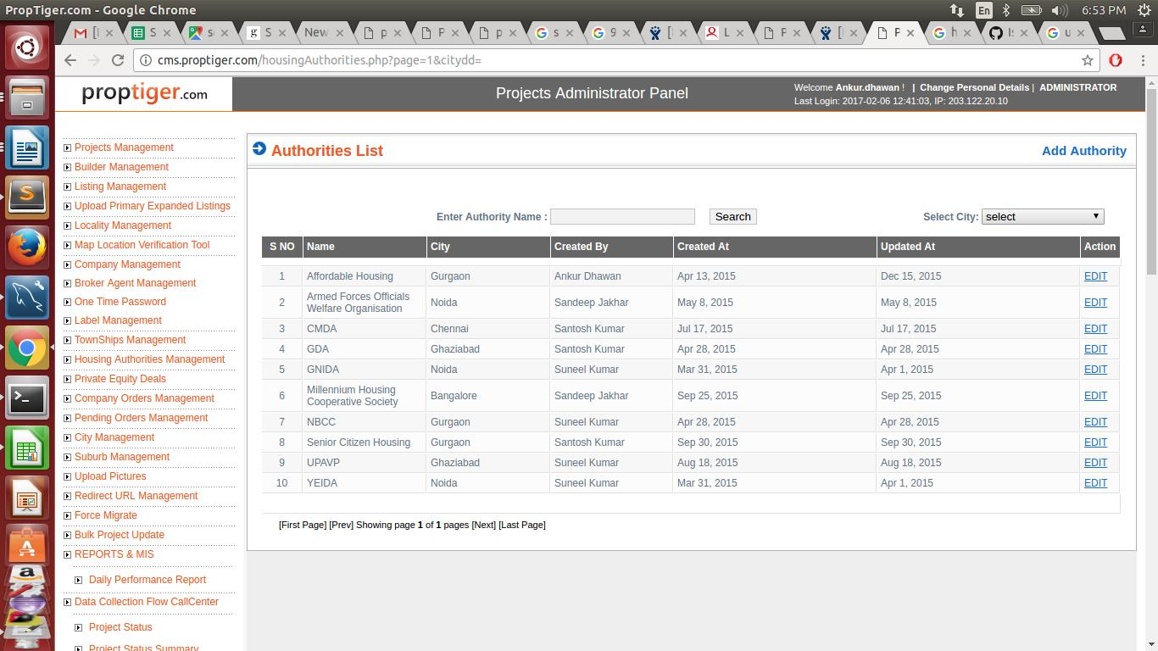

ADD Authority:

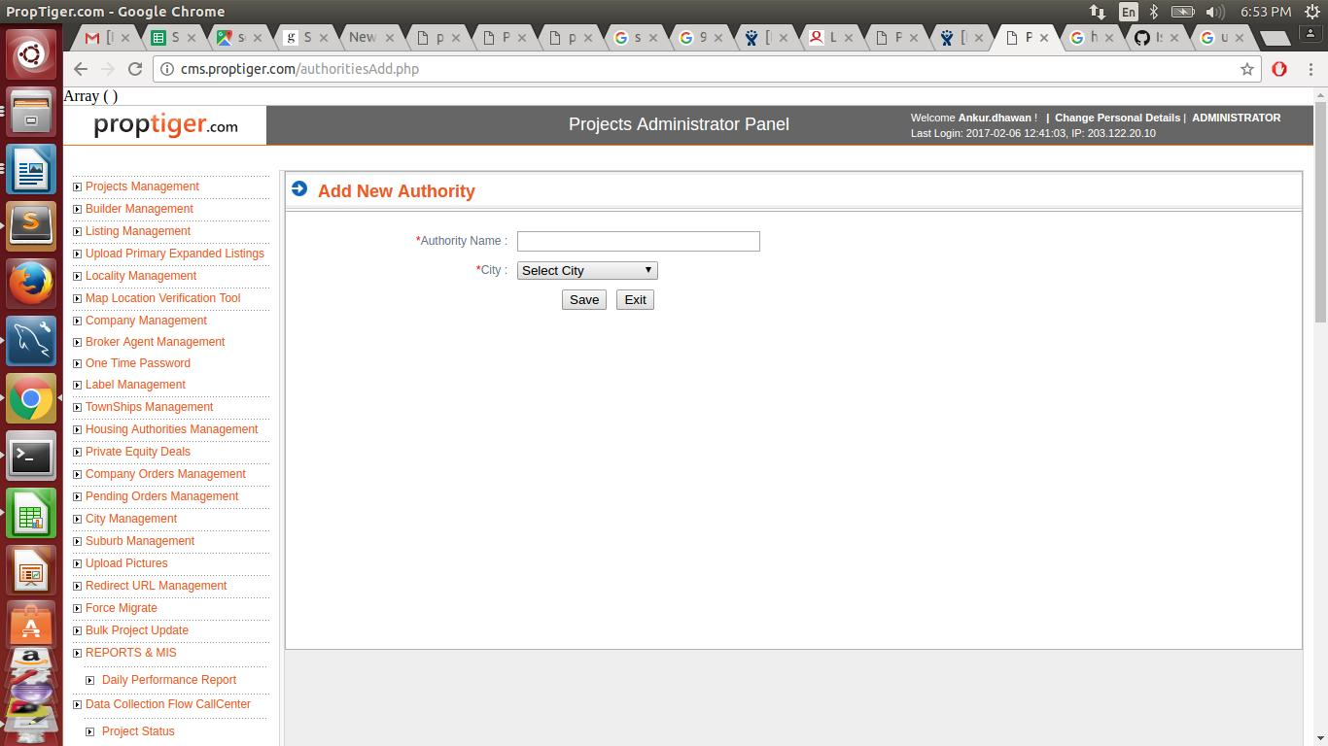

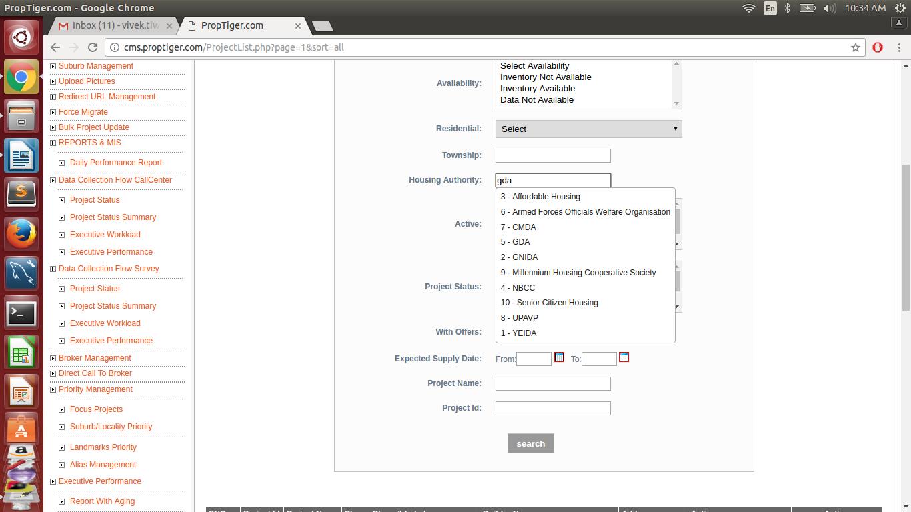

Schema of Housing authority table:

CREATE TABLE `housing_authorities` (
`id` smallint(6) NOT NULL AUTO_INCREMENT,
`city_id` int(11) DEFAULT NULL,
`authority_name` varchar(100) NOT NULL,
`updated_by` int(11) DEFAULT NULL,
`created_at` datetime DEFAULT NULL,
`updated_at` timestamp NULL DEFAULT CURRENT_TIMESTAMP,
PRIMARY KEY (`id`),
KEY `fk_h_authority_1` (`updated_by`),
KEY `fk_h_authority_2` (`city_id`),
CONSTRAINT `fk_h_authority_1` FOREIGN KEY (`updated_by`) REFERENCES `proptiger_admin` (`ADMINID`),
CONSTRAINT `fk_h_authority_2` FOREIGN KEY (`city_id`) REFERENCES `city` (`CITY_ID`) ON DELETE NO ACTION ON UPDATE NO ACTION
) ENGINE=InnoDB AUTO_INCREMENT=11 DEFAULT CHARSET=latin1 COMMENT='master table for housing authorities'

